**SWCSF Centennial Newsletter**

**November 2020**

This year marks the 100th anniversary of our club’s founding! To celebrate, we have offered many Centennial related events. Please watch your emails for announcements of future events.

This edition of the Centennial Newsletter focuses on the club’s founding and highlights our club’s unique contribution to Stanford---our scholarship funds. Enjoy the remarkable history and impact of our support to Stanford undergraduate women from San Francisco.

[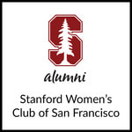](https://alumni.stanford.edu/get/page/groups/overview/?group_id=0038990793)

__________________________________________________________________

**Club’s Founding**

The organizational meeting of our club occurred on April 15, 1920. The STANFORD ILLUSTRATED REVIEW printed an announcement of and report about the meeting, which is posted on the club’s website <http://stanfordwomensclub.org/index.html> . We have archival records for our club going back to the 1920s, including entries for almost all Board and Club members in the Stanford Alumni online Directory.

Since its founding, our club has been led by accomplished, capable women. During the 1920s and 1930s, the 34 women who served on our club’s Board of directors:

* Were born between 1870 and 1915 and were between 21 and 54 years old.
* Lived in San Francisco (before BART, bridges, & commuting).
* Almost all had a Stanford AB degree, with various majors (including: Economics, German Studies, History, Mathematics, Physiology, Zoology, Nursing, and Undergraduate Law).
* Five had Stanford graduate degrees (in English, Entomology, Education, Medicine, and Law).
* All but five were married, and four married Stanford grads.

__________________________________________________________________

**SWCSF Scholarships**

The Stanford Women's Club of San Francisco helps talented women from San Francisco afford a Stanford education, through Scholarships from the Club's two funds, which are managed by Stanford University. Over the past several years, a total of $87,437 per year was paid to deserving women. The SWCSF, its Board, and scholarship recipients appreciate the support from our members.

The two separate scholarship funds are administered by the University’s Financial Aid Office:

**The Stanford Women’s Club of San Francisco Fund** **(SWCSFF)** scholarship was first awarded in 1923. Over the years many events have been held to fund the scholarships. The first for which we have a record was in May 1925. Each attendee contributed 50 cents to the Scholarship Fund (present value of $.50 is $50.00). See the invitation to a fundraising event in 1944 on the next page.

### Every year, money from the SWCSFF is distributed to scholarship recipients. Annual contributions to the fund from the club consist of gifts from individual members and dues money that we have not used to pay for events.

### If you would like to learn more about the SWCSF Scholarship, go to [Groups: Group Overview - Stanford Alumni Association](https://alumni.stanford.edu/get/page/groups/overview/?group_id=0038990793) and sign in to the Stanford Alumni Association. Then click on “Group links – SWCSF Scholarship Fund **.**”

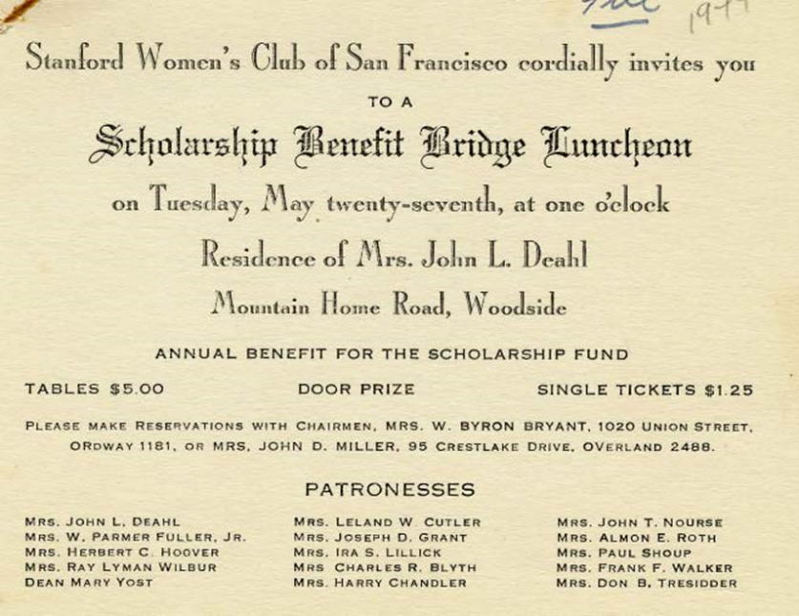

**Invitation to the SWCSF May 1944 Scholarship Benefit Bridge Luncheon** (left)

The patronesses of this 1944 event included Mrs. Herbert C. Hoover and Mrs. Ray Lyman Wilber. Lou Henry Hoover (B.A. 1898, Geology) and Marguerite May Blake (AB 1897, Physiology) were college friends, as were their husbands (Herbert Hoover, AB 1895, Geology, 31st President of the United States, and Ray Lyman Wilbur (AB 1896, MA 1897, MD 1899 Cooper School of Medicine, now Stanford Medical School and the third President of Stanford University)

**The Gladys Louise Meyer Memorial Scholarship Fund (GLMM)** was created from a bequest of $346,000 by Gladys Mortenson (1923-2003, photo at right). She was known as Gladys L. Meyer while at Stanford, and earned two degrees: 1945 AB English, 1952 Education. Gladys was a SWCSF member and must have had a good opinion of our club. She taught English her entire professional life and enjoyed the San Francisco Symphony, Ballet, and Opera. While retired, she attended summer sessions at Stanford. She loved to cook, read, travel, as well as her cats and orchids. It was a happy surprise to our club when we unexpectedly received the bequest, the purpose of which was to fund scholarships for Stanford women, preferably residents of San Francisco. This scholarship was first awarded in 2005.

Gladys Louise Meyer

__________________________________________________________________

**Scholarship Recipients: Lives Impacted by our financial support**

Over the years, more than 125 women have received our scholarships, some for more than one year. We believe that the grants affected their lives positively by providing opportunities to be educated at Stanford and for making contributions to society.

__________________________________________________________________

*“Your group has the longest history of continued support of any of the alumni clubs, and we appreciate it immensely, because we know how hard it is to raise money.”*

--Letter from the Stanford University Committee on Scholarship to the SWCSF President, 9/20/1948

__________________________________________________________________

**Past Scholarship Recipients**

* ***Carol Klink Claussen*** was the first recipient of the SWCSF scholarship. She was born in 1903 and died two weeks after her 100th birthday. She graduated from Stanford in 1925 (AB, English). She received SWCSF scholarship awards in 1923 and 1924. She helped establish the Sacramento chapter of the Girl Scouts of America and was a member of the Charity League, which evolved into the Junior League of Sacramento. She worked as a substitute teacher for more than 20 years until her retirement.
* ***Elizabeth Forbes Bradley*** (1935 AB and MA, History) received the SWCSF scholarship four times: 1932-35.
* ***The Honorable Cynthia Hall*** (1929-2011) was awarded SWCSF scholarships in both 1949 and 1950. She earned an AB in 1951(Undergraduate Law), and a JD in 1954. She was a United States Circuit Judge of the Court of Appeals for the Ninth Circuit and a United States District Judge of the U.S. District Court for the Central District of California. She was the first woman to serve as a law clerk on the Ninth Circuit.

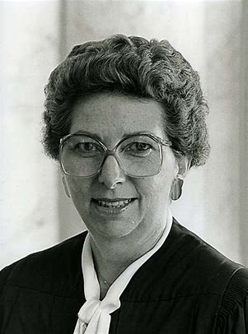

**Recent Scholarship Recipients**

***Sophie Meunier*** (2023 Undecided) was awarded scholarships from both SWCSFF and GLMM in 2019.

***Niza Contreras*** (2020 BS, Earth Systems) was one of two winners of the GLMM scholarship in 2018 and received the award again in 2019.

***Angela Xie*** (BS 2022 Materials Science and Engineering) was the 2018 recipient of the SWCSFF scholarship.

***Lauren Marquez*** (2020 BA, Science, Technology, & Society) was awarded SWCSFF scholarships in 2017 and 2018.

**Sophie Niza Angela Lauren**

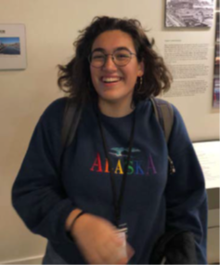 

***Jane Reynolds*** (2010 BA Creative Writing / English) was a 2008 recipient of the SWCSFF and the GLMM Scholarships in 2006. In her 2006 thank-you letter to our club, she said *“While I have been saving my summer earnings and my parents are willing to take out loans, it is still very difficult to finance a college education and your scholarship truly helps to ease some of my concern about how I will pay for college.”*

***Vanisha Amratlal Gandi*** (2010 BA Human Biology) received the SWCSFF scholarship in 2007. In her thank-you letter to Club members, she said *“I know that I would not have been able to even dream about such an educational opportunity if it were not for your scholarship.”*

***Adriana Miu*** (2010 BA Economics, 2010 BA Psychology, 2011 MA (Teaching of Mathematics) Education, 2016 PD (Psychiatry)) was a 2006 recipient of the SWCSFF scholarship. In her thank-you letter to the Club, she said, *“Although I haven’t decided on my major, I would like to be a doctor in the future.”* She did it!

***Leya Elias, winner of GLMM and Truman Scholarships***

Leya Elias (BA 2021 Psychology, Political Science) received the GLMM Scholarship in 2017. In 2020, she was one of 62 U.S. college students to receive a Truman Scholarship. This award provides support for graduate school in preparation for careers in public service (<https://news.stanford.edu/2020/04/16/two-stanford-students-named-truman-scholars/>). Leya’s ambition is to earn a law degree and become a public defender. After receiving the Truman award, she said, *“Receiving this scholarship only further strengthens my commitment to serving my communities with compassion, humility and dedication.”*

**[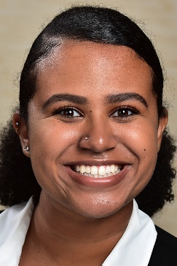](https://news-media.stanford.edu/wp-content/uploads/2020/04/16101641/LeyaElias_1000x1500.jpg)**

Leya Elias

__________________________________________________________________

**Quotes about our Scholarship from the Club’s Archives:**

*“The Board of Directors of the Stanford Women’s Club of San Francisco, by action taken at its meeting on April 3, 1951, has raised the scholarship to be offered for the year 1951-52 to the amount of $660. The original purpose of the scholarship was to pay one full year’s tuition for a deserving San Francisco woman, and since that cost has risen during the past few years, we feel it is only proper that the scholarship be raised to meet the new figure. We plan to maintain the scholarship at this amount in the future. Mrs. John S. O’Neill, President*

*--*Letter from the SWCSF President to the Stanford University Scholarship Secretary, June 7, 1951

*“…I have learned that the Stanford Women’s Club of San Francisco has increased its scholarship beginning with the year 1951-52 to cover full tuition for one student. Please express to the Board of Directors and to the members of your Club my appreciation for this action. The aid you have given women students from San Francisco over these many years has meant much to them and to the University.”*

--Letter from J.E. Wallace Sterling, Stanford University President, June 21, 1951